

RELEASE: Immediate

CONTACT: Heywood Sloane Andrew Singer
610-989-9047, x 17 914-381-7475
heywoods@bisanet.org a.singer@singerpubs.com

Thrift Retail Investments Index Drops 16% in the 1st Quarter
Wayne, PA- July 8, 2009: The BISA-Singer’s Thrift Investments Index declined 16 points—or 16 percent—in the first quarter of 2009, the Bank Insurance and Securities Association (BISA) announced today.

“In the first quarter, the Index fell well below the baseline that was established in the first quarter of 2007,” said Heywood Sloane, Managing Director of the Bank Insurance and Securities Association. “Thrift brokerage programs continue to feel the effects of the recession.”

The Index is an average based on the change in quarterly investments income at 10 thrift institutions (see table below) with mature retail investments programs. It sets 2007 1st quarter as a baseline (100). The Index declined from 99 in the 4th quarter of 2008 to 83 in the 1st quarter of 2009. Aggregate investment revenues of the 10 thrifts covered fell more dramatically—27 percent (see table below)—from $35.1 million to $25.5 million.

Investment revenues are defined as income from “the sale and servicing of mutual funds and annuities” as reported each quarter to the Office of Thrift Supervision (OTS). These packaged investment products comprise the vast majority of revenues in thrift retail brokerage programs, often more than 90 percent.

The Index is produced jointly by BISA and Singer’s Annuity & Funds Report, who also generate the BISA-Singer’s Bank Brokerage Index, which tracks bank annuity and securities revenues in commercial banks.

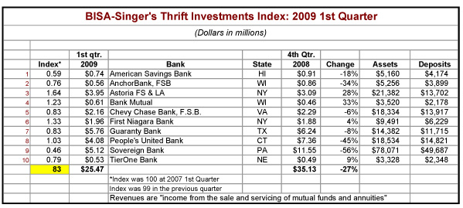

The Bank Insurance and Securities Association (BISA) is the Association of choice for firms and financial professionals who wish to successfully engage in the distribution of integrated financial services including investments and insurance through depository institutions. Its mission is to support member firms and financial professionals within depository institutions by building a community and providing forums to enhance their professionalism, knowledge, and productivity to help them best serve their clients with a broad array of financial solutions.

Singer’s Annuity & Funds Report is published by the Bank Insurance Market Research Group, which also publishes Who’s Who in Bank Insurance and Who’s Who in Bank Wealth Management. It also produces Singer’s ‘100’ Bank Brokerage Index and Singer’s ‘125’ Thrift Investments Index.

NOTE: Credentialed members of the press may obtain additional information by calling Heywood Sloane at 610-989-9047, x 17.

