

RELEASE: Immediate

CONTACT: Heywood Sloane Andrew Singer
610-989-9047, x 17 914-381-7475
heywoods@bisanet.org a.singer@singerpubs.com

Bank Brokerage Index Edges Up 1 Percent in 1st Quarter
Wayne, PA- July 2, 2009: The BISA-Singer’s Bank Brokerage Index edged up 1 percent in the first quarter of 2009, the Bank Insurance and Securities Association (BISA) announced today.

The Index is an average based on quarterly brokerage revenues at 20 operating banks (see table below) with established retail investments programs. It sets 2007 1st quarter as a baseline (100). The index rose from 108 in the 4th quarter of 2008 to 109 in the first quarter of 2009. Aggregate brokerage revenue of the 20 banks covered fell 4 percent (see table below)—from $174.17 million to $166.74 million.

“An increase in annuities revenues compensated for a decline in securities brokerage revenues in the quarter,” said Heywood Sloane, Managing Director of the Bank Insurance and Securities Association.

Brokerage revenues are comprised of two groups: annuities (“fees and commissions from sales of annuities”) and securities (“fees and commissions from securities brokerage activities”) as reported to the FDIC.

“Annuities now comprise 68 percent of brokerage revenues,” said Sloane, “which is their highest share by far since the baseline was established” (see chart below). By comparison, annuities accounted for only 52 percent of brokerage revenues in the first quarter of 2007.

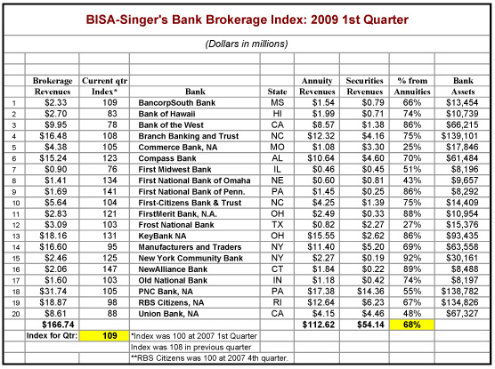

The Index is produced jointly by BISA and Singer’s Annuity & Funds Report.
The Bank Insurance and Securities Association (BISA) is the Association of choice for firms and financial professionals who wish to successfully engage in the distribution of integrated financial services including investments and insurance through depository institutions. Its mission is to support member firms and financial professionals within depository institutions by building a community and providing forums to enhance their professionalism, knowledge, and productivity to help them best serve their clients with a broad array of financial solutions.

Singer’s Annuity & Funds Report is published by the Bank Insurance Market Research Group, which also publishes Who’s Who in Bank Insurance and Who’s Who in Bank Wealth Management, as well as Singer’s ‘100’ Bank Brokerage Index.

NOTE: Credentialed members of the press may obtain additional information by calling Heywood Sloane at 610-989-9047, x 17.

