

RELEASE: Immediate

CONTACT: Heywood Sloane Andrew Singer
610-989-9047, x 17 914-381-7475
heywoods@bisanet.org a.singer@singerpubs.com

Bank Brokerage Index Falls 11 Percent in 2nd Quarter
Wayne, PA- September 24, 2009: The BISA-Singer’s Bank Brokerage Index dropped 11 percent in the second quarter of 2009, the Bank Insurance and Securities Association (BISA) announced today.

The Index is an average based on quarterly brokerage revenues at 20 operating banks (see table below) with established retail investments programs. It sets 2007 1st quarter as a baseline (100). The index fell from 109 in the 1st quarter of 2009 to 98 in the second quarter of 2009, the first time the Index has slipped below 100. Aggregate brokerage revenue of the 20 banks covered fell 6 percent (see table below)—from $166.74 million to $156.56 million. Only four of the 20 banks in the Index improved their brokerage performance in the 2nd quarter.

“Aggregate annuities revenue plunged 15 percent in the quarter, which accounted for the brokerage decline—since annuities account for 61 percent of brokerage revenues,” said Heywood Sloane, Managing Director of the Bank Insurance and Securities Association. Annuities accounted for 68 percent of brokerage revenues in the previous quarter.

A resurgent stock market largely accounted for the 13 percent gain in aggregate securities revenues at the 20 banks in the Index.

Brokerage revenues are comprised of two groups: annuities (“fees and commissions from sales of annuities”) and securities (“fees and commissions from securities brokerage activities”) as reported to the FDIC.

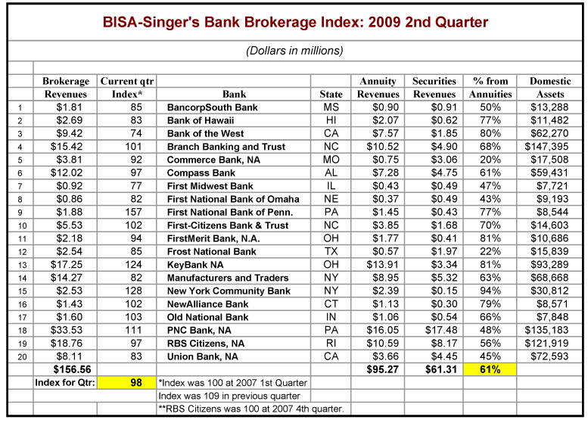

The Index is produced jointly by BISA and Singer’s Annuity & Funds Report.
The Bank Insurance and Securities Association (BISA) is the Association of choice for firms and financial professionals who wish to successfully engage in the distribution of integrated financial services including investments and insurance through depository institutions. Its mission is to support member firms and financial professionals within depository institutions by building a community and providing forums to enhance their professionalism, knowledge, and productivity to help them best serve their clients with a broad array of financial solutions.

Singer’s Annuity & Funds Report is published by the Bank Insurance Market Research Group, which also publishes Who’s Who in Bank Insurance and Who’s Who in Bank Wealth Management, as well as Singer’s ‘100’ Bank Brokerage Index.

NOTE: Credentialed members of the press may obtain additional information by calling Heywood Sloane at 610-989-9047, x 17.

