

RELEASE: Immediate

CONTACT: Heywood Sloane Andrew Singer
610-989-9047, x 17 914-381-7475
heywoods@bisanet.org a.singer@singerpubs.com

Bank Brokerage Index Drops 1 Percent in 3rd Quarter
Wayne, PA- January 7, 2009: The BISA-Singer’s Bank Brokerage Index declined 1 percent in the third quarter of 2008, the Bank Insurance and Securities Association (BISA) announced today.

The Index is an average based on quarterly brokerage revenues at 20 operating banks (see table below) with established retail investments programs. It sets 2007 1st quarter as a baseline (100). The index declined from 120 in the 2nd quarter of 2008 to 119 in the third quarter.

“Despite the quarterly decline, the Index is still 19 percent above the baseline (2007 1st quarter), and up 5 percent compared with the same quarter of the previous year,” said Heywood Sloane, Managing Director of the Bank Insurance and Securities Association.

Brokerage revenues are comprised of two groups: annuities (“fees and commissions from sales of annuities”) and securities (“fees and commissions from securities brokerage activities”) as reported to the FDIC.

“Annuities now comprise 58 percent of brokerage revenues,” said Sloane, “which is their highest share since the baseline was established (see chart below). By comparison, annuities accounted for only 52 percent of brokerage revenues in the first quarter of 2007.”

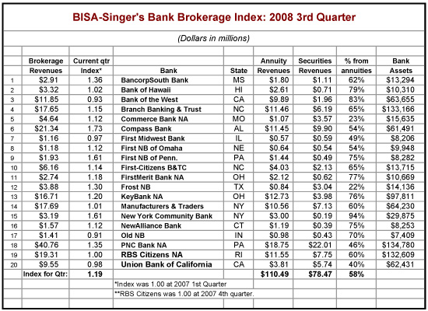

The Index is produced jointly by BISA and Singer’s Annuity & Funds Report.
The Bank Insurance and Securities Association (BISA) is the Association of choice for firms and financial professionals who wish to successfully engage in the distribution of integrated financial services including investments and insurance through depository institutions. Its mission is to support member firms and financial professionals within depository institutions by building a community and providing forums to enhance their professionalism, knowledge, and productivity to help them best serve their clients with a broad array of financial solutions.

Singer’s Annuity & Funds Report is published by the Bank Insurance Market Research Group, which also publishes Who’s Who in Bank Insurance and Who’s Who in Bank Wealth Management.

NOTE: Credentialed members of the press may obtain additional information by calling Heywood Sloane at 610-989-9047, x 17.

